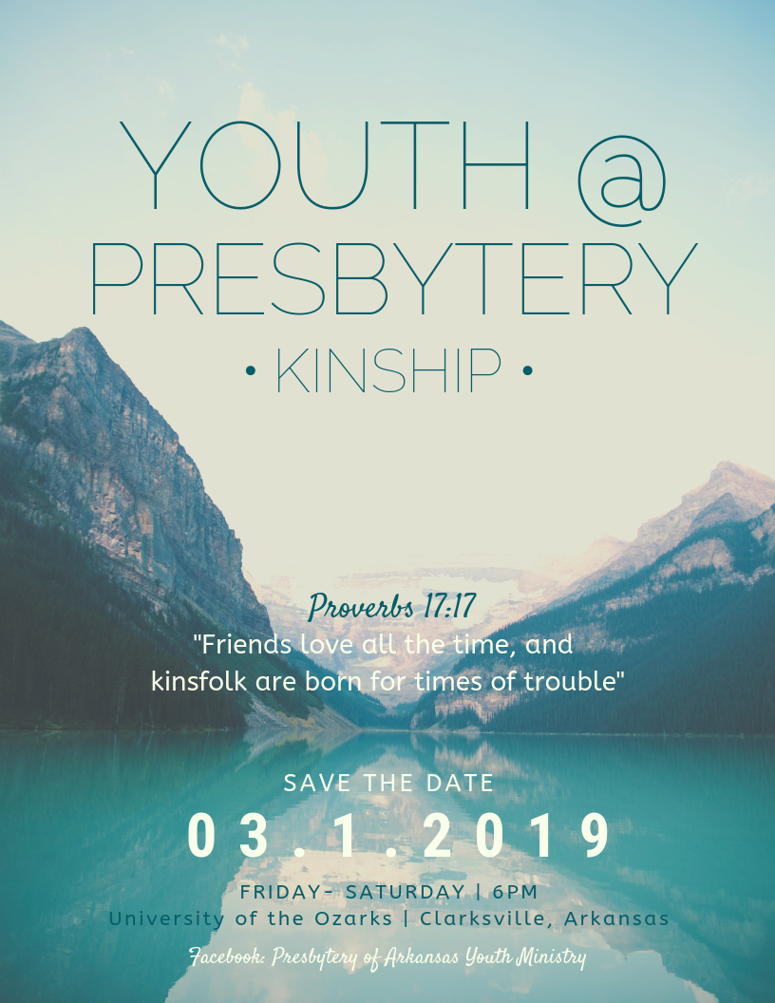
Youth at Presbytery FAQs
What is Youth at Presbytery?
- Youth at Presbytery is a chance for young leaders in your congregation to learn about and participate in our connectional church by attending parts of the Presbytery of Arkansas winter meeting and having the chance to cast Advisory Votes. Interspersed with all that, there will be lots of time for joining in fellowship with other youth, playing games, and having fun!
When does the event start and end?
- The presbytery meeting begins at 6:00 pm. The event ends when the Presbytery meeting ends on Saturday. Depending on the amount of business brought to the meeting, it will probably end mid-afternoon. Youth can arrive late. The meeting will begin in the Munger-Wilson Chapel.
Who sponsors this event?
- This event is sponsored by the Presbytery of Arkansas Youth Advisory Team (YAT), a sub-committee of the Presbytery that includes 10th-12th grade youth, college students, and adults from churches all across the Presbytery who care about young people and Youth Ministry. The YAT plans events and trips, which are open to all youth in the Presbytery. If you are interested in serving on the YAT or if you have questions, please contact the 2018-2019 YAT Co-Moderator, Sarah Leer at 479-462-6902.
How do I register?
- Please fill out the attached Registration Form and mail it, with the $25 fee (checks made out to Presbytery of Arkansas), to the Presbytery Office. Registrations must arrive by Monday, February 25. The address is on the registration form. You can also scan your completed form and email it to Stewart Smith at stewart@presbyteryofarkansas.org.
What happens after I register?
- Prior to the event, you will receive an email with more detailed information, a packing list, a schedule, and a medical form that you will bring to registration.
Do we need to send adults with the youth from our church?
- No. The Youth Advisory Team will provide adults who will lead and chaperone the youth in attendance. These adults are active in youth ministry in the Presbytery and serve on the Youth Advisory Team. If you would like to send an/some adult(s) to attend the event with your youth, we would love to have them! Adults should send in the Registration Form and fee. They will house at the church with the youth. All adults participating in the event will need to complete a background check (contact Hannah at hlahodny@gmail.com).
Where do the youth sleep?
- Youth will be sleeping at the newly renovated space below the Munger-Wilson chapel at the University of the Ozarks.

What does the $25 fee cover?

- The fee covers a heavy snack on Friday night, breakfast and lunch on Saturday, an event memento, and all other materials for the weekend. Participants should eat dinner before arrival on Friday.
How many youth can I send from my church?
- The event is targeted for leaders in your youth group or church. Most churches send two to five youth.
How do we get to Youth at Presbytery?
- Participants are responsible for providing their own transportation to Youth at Presbytery. We highly encourage youth to carpool with the adults coming to the meeting from their church.
Are there scholarships available?
- The Presbytery has limited scholarship money available for those with financial need. For information about receiving a partial scholarship for this event, please contact Sarah Leer at sleer@fpcbentonville.org.
Who can I contact to ask questions?
- Please contact General Presbyter Stewart Smith, at 501-663-2424 or stewart@presbyteryofarkansas.org or Loretta Mansell, Event Director, at 479-466-3944.
How do I find out more about Presbytery of Arkansas Youth Ministry Offerings?
- “Like” our Facebook Page! https://www.facebook.com/PresbyteryOfArkansasYouthMinistry Or check out our website: http://www.presbyteryofarkansas.org/frmYouthCouncil.aspx You’ll find information there to keep you updated about these trips and other offerings by the Presbytery!

Youth at Presbytery 2019 Registration and Personal Information Form
Send to: Presbytery of Arkansas Y@P Registration 9221 N. Rodney Parham Road Little Rock, AR 72227 With $25 fee by February 25, 2019.

Church: ________________________________________________ City/State: _________________________
Youth Name: ______________________________________________________________________________
Mailing address: ___________________________________________________________________________
City: __________________________________________ State: ________________ Zip: _________________
Gender: M F Grade: __________ Birthdate: _____________ Youth cell:__________________________
Youth email: _________________________________________________________________
Home phone: ________________________________________________________________
Parent/ Guardian info:
Name: _____________________________ Cell: _________________________________
Email: ________________________________
Questions for the participant:
Are you an Elder or Deacon at your home church? Will you be serving as an Elder Commissioner for your home church for this meeting? [ ] yes [ ] no
To be signed by a Pastor, Youth Director, or Clerk of Session from your church:
[ ] Yes, we are excited to send this young person to Youth at Presbytery! We will support him/ her in thought and prayer before and during the weekend.
_____________________________________________ ___________________ Signature/Date

