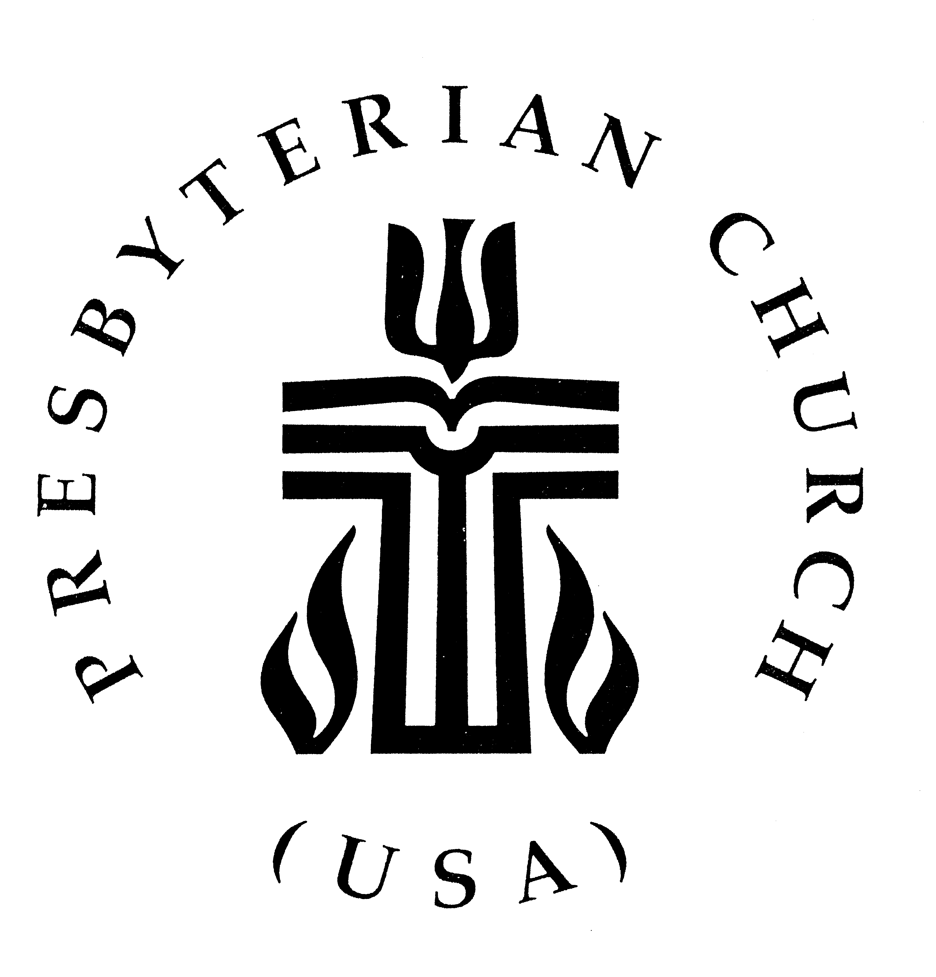

143rd Stated Meeting
of the Presbytery of Arkansas
Friday-Saturday, March 6-7, 2020
Lyon College
Batesville, Arkansas

Proposed Amendments
to the Presbytery of Arkansas’
Ministry Manual

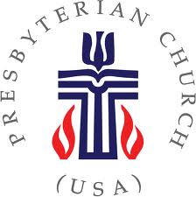
PRESBYTERY OF ARKANSAS
9221 North Rodney Parham Road

Little Rock, Arkansas 72227

501.663.2424 • 501.224.2429 FX

www.presbyteryofarkansas.org • info@presbyteryofarkansas.org

February 4, 2020

Dear Brothers and Sisters in Christ,

At the February 9-10, 2018 meeting of the Presbytery of Arkansas the Presbytery approved various amendments to the Presbytery’s Ministry Manual. Since that time the Presbytery has re-emphasized the three priorities of the Presbytery, which are;

- Building strong congregations that faithfully and effectively share the gospel through mission and ministry;
- Connecting congregations, resources and expertise to support life giving practices in congregations and fellowships; and
- Developing and supporting ministries with youth and young adults, including collegiate and campus ministry;

and has re-oriented the various ministries of the Presbytery so that we may better live into those priorities.

Continuing to better enable the Presbytery to live into God’s call, the Coordinating Team requests that the Presbytery again consider amending the Ministry Manual. The Presbytery of Arkansas’ Ministry Manual is divided into five parts: “Part I, Organization and Structure” explains the structure of our Presbytery; “Part II, Ministry and Committees Duties” outlines the duties of the various ministry areas, committees, and sub-committees making up that structure; “Part III, Standing Rules” is the compilation of the various standing rules that the Presbytery has approved through the years; the Presbytery’s documents necessary for how we do our work are in “Part IV, Policies and Procedures;” and in “Part V, Covenants and Partnerships” one can find the covenants we have with our partner organizations.

Amendments to “Part I, Organization and Structure” of the Ministry Manual are to be distributed to the Presbytery at least 30 days in advance of any meeting at which those amendments will be voted on, and, along with the Standing Rules, need a 3/5 majority vote to be approved or adopted. The 30-day notice may be waived by a 2/3 vote of the Presbytery. Other parts of the Ministry Manual require only a simple majority to amend and have no stipulation on how much notice must be given prior to a vote.

This special packet includes proposed amendments to three parts of our Ministry Manual, primarily the first two parts. There are four goals hoped to achieve through the proposed revisions:

- Simplify the process of electing committee members so that those who are most interested may serve rather than specifically emphasizing regional representation as the means to achieve diversity;
- Reduce the number of people needing to be recruited;
- Encourage those ministry areas/committees whose missions need to be coordinated to work across ministry area/committee borders (Mission/Future/Y,YA,CM)(COM/CPM); and
- Simplify the way that people understand the Presbytery structure.
I invite you to prayerfully read the proposed amendments. The proposed amendments have been reviewed and enthusiastically supported by the remaining members of the Listening Team who wrote the Ministry Manual approved by the Presbytery of Arkansas in 2016. In the words of RE Michael Szabo, a member of that team, “the Listening Team agrees and supports your recommendations and that they are 100% congruent with what the Presbytery told us they wanted; and also that we always considered that the structure would be fluid based on changing needs. We worked hard to build flexibility into the structure so that it could be ‘results’ oriented with the emphasis on function over form. We wanted the committees to be empowered to use their imagination to produce the best results possible and not be limited by an overly constrictive structure.”

The five parts of the Ministry Manual may be viewed as they currently exist on the Presbytery of Arkansas’ website , www.presbyark.org, under “Resources,” and “Presbytery Documents: Stated Clerk” If you have any questions about the process, or the proposed amendments themselves, please contact me at lesliebeld@aol.com or 479.466.1061. I am yours…

In Christ,
MWS Leslie Belden
Stated Clerk
Presbytery of Arkansas

J. Stewart Smith Kim Porter Leslie Belden Brianne Christiansen
General Presbyter Office Manager Stated Clerk Director of Youth Ministries

The Vision of the Presbytery of Arkansas is:
to “make visible the body of Christ.”

The Mission of the Presbytery of Arkansas is:

“Trusting that we serve God better together, we are a family of congregations, ministries, and their leaders empowering and supporting one another to embody Christ’s love for all.”

The work of the Presbytery of Arkansas is essentially divided among three specific functions:
- Empowering and enabling the mission and vision of the congregations and ministries of the Presbytery, particularly as pertains to the three priorities of the Presbytery;
- Assisting congregations in the provision of pastoral leadership, including preparing those called for such leadership, and counseling with congregations and sessions in the ministry of their leadership roles; and
- Providing the administrative support that a governing body as an institution needs, both functionally and within the constitutional mandates of the PC(USA).
The proposed amendments to the Ministry Manual are intended to congregate the three functions of the Presbytery together, organizing the Ministry Manual in a simpler way.

Mission and Vision: Leadership and Ministry:
Committee on Mission of the Church Committee on Prep. for Ministry
Committee on Youth, Young Adults, and Campus Ministry Committee on Ministry
Committee on the Future of the Church

Leadership and Ministry

Mission and Vision

Coordinating Team

Institutional Support

Institutional Support:
Committee on Administration
Committee on Representation
Committee on Nominations
Permanent Judicial Commission
Ministry Manual Amendments’ Ramifications on Quantity of Volunteers
Needed to Fill the Presbytery of Arkansas’ Committee Structure

Coordinating Team
Presently: 22 (10 of whom serve on other ministries/committees so the total positions needing to be elected is 12)
Proposed: 10 (6 of whom serve on other committees so the total positions needing to be elected would be 4)
Change: 12 fewer

Institutional Support Tasks

Administration
Presently: 7
Proposed: 6
Change: 1 fewer

Representation
Presently: 8
Proposed: 6
Change: 2 fewer

Nominations
Presently: 10
Proposed: 9
Change: 1 fewer

PJC
Presently: 12
Proposed: 12
Change: none

Leadership and Ministry Tasks

Committee on Preparation for Ministry
Presently: 11
Proposed: 9
Change: 2 fewer

Committee on Ministry
Presently: 24
Proposed: 81
Change: 6 fewer

Mission and Vision Tasks

Mission of the Church Youth/Young Adult/Campus Future of the Church
Presently: 13 + 1 Presently: 11 Presently: 14
Proposed: 9 +1 Proposed: 6 Proposed: 9
Change: 4 fewer Change: 5 fewer Change: 5 less

Total volunteers needed to fill current structure (not including subcommittees): 133
Total volunteers needed with proposed amendments (not including subcommittees): 95

Total reduction in volunteers needed: 33

Rationale for Proposed Amendments

Part I - Organization and Structure (requires 3/5 vote to approve)

- Include the Mission Statement of the Presbytery, as approved by the Presbytery;
- Conform to the Book of Order’s terminology;
- Not require Honorably Retired Ministers of the Word and Sacrament to submit an excuse to be absent from a Presbytery meeting;
- Eliminate the term “confirmed” when referring to members;
- Group committees of the Presbytery of Arkansas into three primary categories;
- Use “committee” and “subcommittee” terminology to simplify references;
- Reduce the number of volunteers required to fill the structure;
- Provide consistency in language;
- Broaden the understanding of representation beyond geographical representation and eliminate specific designations such as “majority”;
- Include the membership requirements of all committees in this part of the Ministry Manual; and
- Simplify the election and terms of members of the Coordinating Team to be consistent with other committees.
Part II – Ministry and Committee Duties (requires a simple majority to approve)

- Provide consistency in language;
- Align the Ministry Manual with actual practices of committees;
- Change the term “ministry areas” to “committees”;
- Include introductory language to the two new primary categories that is consistent with the introductory language grouping the Committee on Preparation for Ministry and the Committee on Ministry;
- Remove first person plural language;
- Designate that all subcommittees recruit their own members rather than the Committee on Nominations; and
- Add language to Youth, Young Adults, and Campus Ministry to reflect the visioning of that group.
Part III – Standing Rules (requires a 3/5 majority to approve)
.
- Standing Rule #1 – Only a week is needed to incorporate business.
- Standing Rule #2 - The amount of time demanded by some committees is less than others, and the Committee on Nominations can take that into account without a restrictive Standing Rule.
Proposed removal of language is so designated by striking through the words to be deleted.
Proposed additions of language is so designated by highlighting those words in red.

